Reva Scharf

Caitlin Manes

2/14/15

HW2 Write Up

The purpose of this homework was to work in pairs to obtain the output characteristic of one of the GPIO pins. We chose to use pin 1.0. Our measurements were obtained by using a circuit viewable in the below Figure 1.

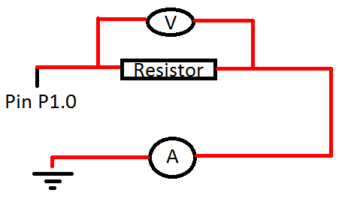

Figure : Circuit diagram

The following table (Table 1) and V-I curve (Figure 2) details our results for the high pin output. The values used for our resistors (eight in total) can be seen in the table.

|  |  |  |
| --- | --- | --- |
| V-I Curve Data for High Pin Output | | |
| Resistors in ohms | Current (measured in amps) | Voltages measured in volts |
| 10 | 0.0693 | 0.689 |
| 100 | 0.0285 | 2.81 |
| 180 | 0.0169 | 3.1 |
| 470 | 0.00711 | 3.33 |
| 1000 | 0.00343 | 3.38 |
| 2200 | 0.00159 | 3.43 |
| 56000 | 0.000063 | 3.47 |
| 220000 | 0.000016 | 3.48 |

Table : V-I Curve Data for High Pin Output

Figure : V-I Curve for High Pin Output

The following table (Table 2) and V-I curve (Figure 3) details our results for the low pin output. The values used for our resistors (eight in total) can be seen in the table. They are the same as for the high pin data.

|  |  |  |
| --- | --- | --- |
| V-I Curve Data for Low Pin Output | | |
| Resistors in ohms | Current (measured in amps) | Voltages measured in volts |
| 10 | 0 | 0 |
| 100 | 0 | 0.0001 |
| 180 | 0 | 0.0001 |
| 470 | 0 | 0.0001 |
| 1000 | 0 | 0.0001 |
| 2200 | 0 | 0.0002 |
| 56000 | 0 | 0.0002 |
| 220000 | 0 | 0.0002 |

Table : V-I Curve Data for Low Pin Output

Figure : V-I Curve for Low Pin Output